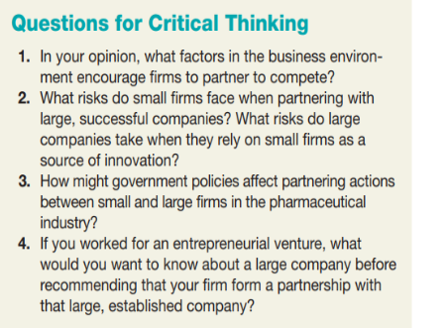

Here are detailed answers to the critical thinking questions about business partnerships:

1. \*\*Factors Encouraging Partnerships to Compete\*\*:

- \*\*Market Expansion\*\*: Partnering can help firms access new markets by leveraging each other's strengths, such as established customer bases or regional expertise.

- \*\*Resource Sharing\*\*: Sharing resources like technology, expertise, and capital can reduce costs and risks associated with new projects.

- \*\*Innovation Boost\*\*: Collaboration can spur innovation as firms combine different skills, technologies, and perspectives.

- \*\*Regulatory Compliance\*\*: Sometimes partnerships are formed to meet certain regulatory standards more effectively together than alone.

2. \*\*Risks in Small vs. Large Firm Partnerships\*\*:

- \*\*For Small Firms\*\*:

- \*\*Dependency Risks\*\*: Becoming overly dependent on the larger firm for resources or market access.

- \*\*Loss of Control\*\*: Potential loss of control over business decisions and intellectual property.

- \*\*Dilution of Brand\*\*: Risk of diluting their brand or being overshadowed by the larger partner.

- \*\*For Large Firms\*\*:

- \*\*Innovation Risks\*\*: Dependence on the innovation of smaller firms can be risky if the smaller firm fails to deliver.

- \*\*Agility Issues\*\*: Smaller firms are typically more agile and innovative, which might pose integration challenges.

- \*\*Cultural Misalignment\*\*: Potential for cultural clashes that can affect the effectiveness of the partnership.

3. \*\*Impact of Government Policies on Partnerships in Pharmaceuticals\*\*:

- \*\*Regulatory Environment\*\*: Strict regulations can drive firms to partner to share the burden of compliance and leverage each other's regulatory expertise.

- \*\*Funding and Incentives\*\*: Government grants, subsidies, or tax incentives for research collaborations can encourage partnerships.

- \*\*Intellectual Property Laws\*\*: Strong IP protection laws can make firms more willing to share knowledge and innovations.

4. \*\*Considerations Before Partnering with a Large Firm\*\*:

- \*\*Financial Health\*\*: Understanding the financial stability of the large company is crucial.

- \*\*Strategic Alignment\*\*: The goals and values of the large company should align with those of your entrepreneurial venture.

- \*\*Reputation\*\*: The large company’s market reputation can impact your firm’s brand.

- \*\*Previous Partnerships\*\*: Insights into how previous partnerships were handled by the large company can indicate potential future experiences.

- \*\*Exit Strategy\*\*: Clarity on the terms of disengagement if the partnership does not work as expected.